FRASER BARKER

1600196

1600196@uad.ac.uk

ASSESSMENT REPORT

CMP305

Contents

Features 2

Controls 2

Camera 2

ImGui 2

Smoothing 3

Faulting 3

Circle Algorithm 3

Midpoint Displacement 3

Simplex Noise 3

Fractal Brownian Motion 3

Voronoi Regions 3

Terrain Picking 3

L-Systems 3

Organisation 4

Terrain 4

L-System 4

Sizeable Quad 4

Simplex Noise 4

Terrain Shader 4

Manipulation Shader 4

Critical Appraisal 5

Terrain Class 5

L-System 5

Tessellation 5

Overall 5

Changes 5

Reflection 6

Topics 6

Further/Alternative Applications 6

References 7

# Features

1. An outline of the general features of your program
2. A description of features such as visual and sound effects or interactivity.

## Controls

### Camera

The camera can be moved around the scene using the following controls.

* W – Move forward.
* S – Move backwards.
* A – Move left.
* D – Move Right
* Q – Move down.
* E – Move up.
* Spacebar – Toggle camera rotation via mouse/free mouse from screen boundaries.
* Up Arrow – Tilt up.
* Down Arrow – Tilt down.
* Left Arrow – Rotate left.
* Right Arrow – Rotate right.
* Mouse – Used to rotate the camera more freely around the scene. Can be toggled via Spacebar.
* Left Mouse Button – If picking is enabled, this will displace the terrain upwards.
* Right Mouse Button – If picking is enabled, this will displace the terrain downwards.

### ImGui

The application has a GUI integrated into which allows the user to alter specific values relating to the terrain in real-time rather than having to map specific functions to certain keys.

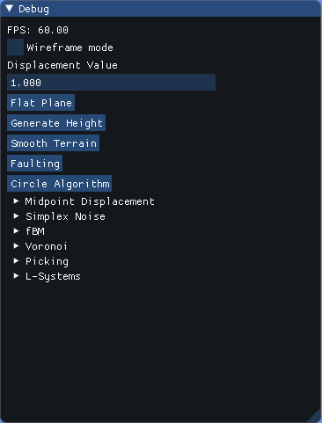

When the user has the mouse unlocked from the centre of the screen, they can interact with the above ImGui menu. As you can see, the menu is composed of many sections which relate to specific terrain altering functions. These functions are detailed below.

## Basic Features

The ImGui menu show the current framerate of the application. This is useful as it really shows just how terrible that one function you wrote really was as you watch the framerate plummet.

It also has a “Wireframe mode” toggle which - as the name suggests - allows the user to see all the objects in the scene in their wireframe mode.

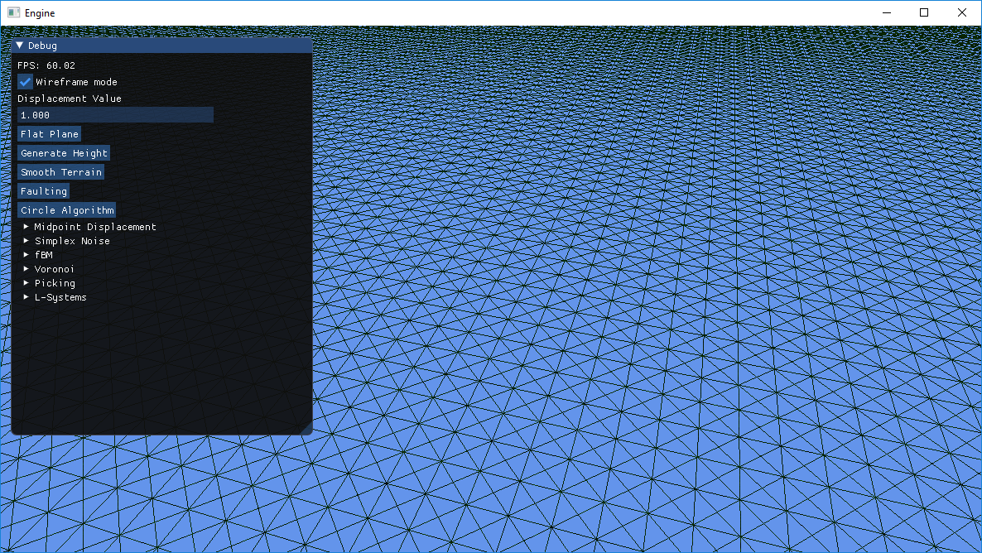

The displacement value is a float that is passed into most - if not all - of the terrain altering functions to determine how much the terrain should be displaced by. This may have been a poor choice, as you can sometimes forget you set it to a high value when you begin experimenting with other features, which starts to cause bizarre results.

The button “Flat Plane” simply does as the name suggests, acting as a reset button it allows the user to revert the terrain back to its default flat state.

The button “Generate Height” was more of an introductory feature that kind of just stuck around. Very basic, in that all it does is loop through the terrain’s vertices array assigning random values to the y-position at each point.

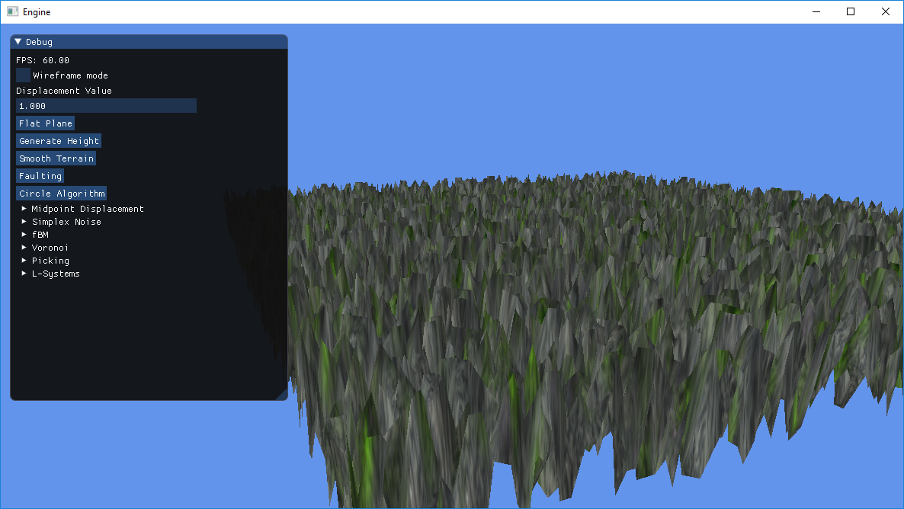

## Smoothing

Following the *Simple terrain smoothing* blogpost, the Smoothing function again loops through the terrain’s vertices array checking the neighbours of each vertex and averages the value for the y-position. Below are two pictures of smoothing the above generated height displaced terrain.

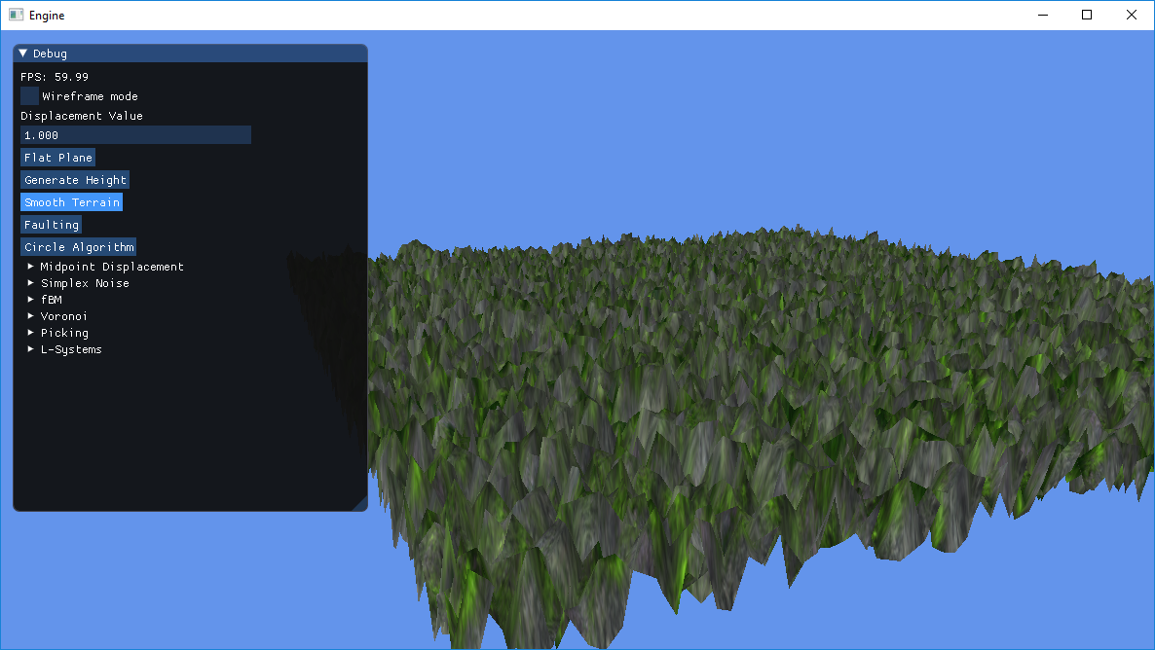

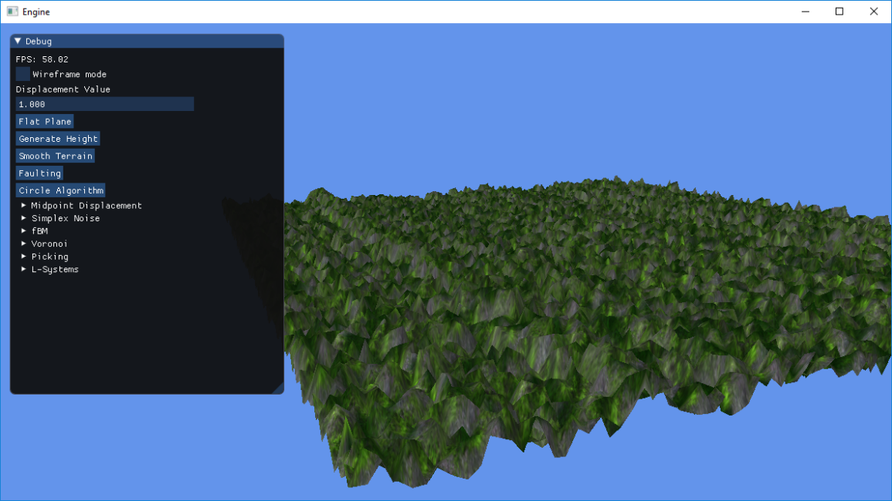

Its current implementation could do with a bit of refinement, but I’ll cover this in the Critical Appraisal section.

## Faulting

The Faulting function utilises the fault line algorithm (as detailed in *The Fault Algorithm*). This works based on choosing two random points at each side of the plane, drawing a line between them and depending on what side of the line a vertex is, its position is either raised or lowered.

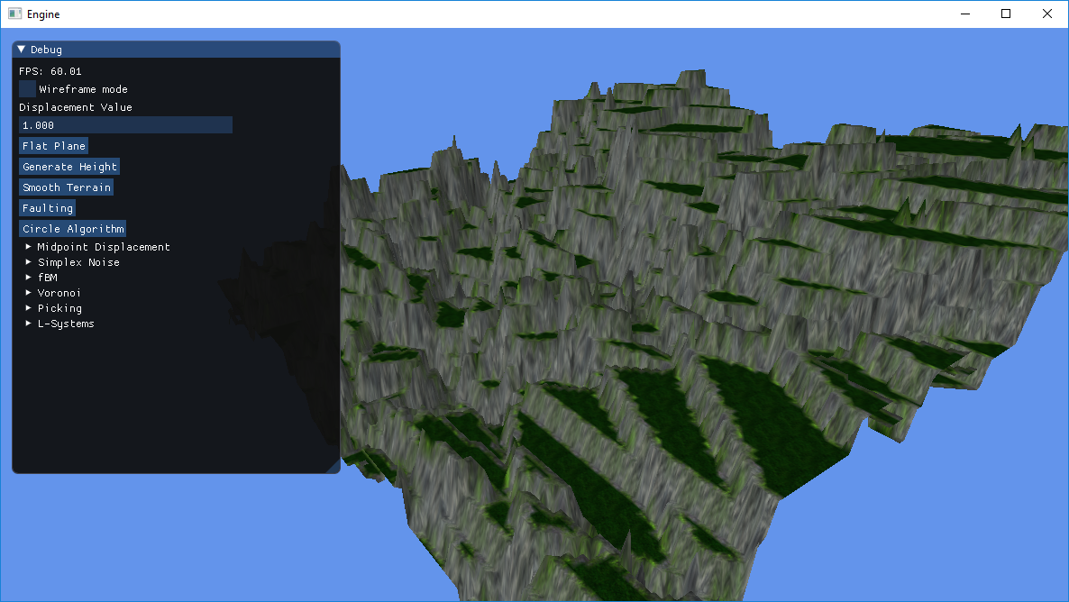

## Circle Algorithm

Quite possibly my favourite function of the application. There are two variations of this function; a random circle algorithm and a refined circle algorithm which is used in the terrain picking function. The random circle algorithm loops one hundred times choosing random points on the plane to alter based on whether a vertex is within a circle of random radius around the random point.

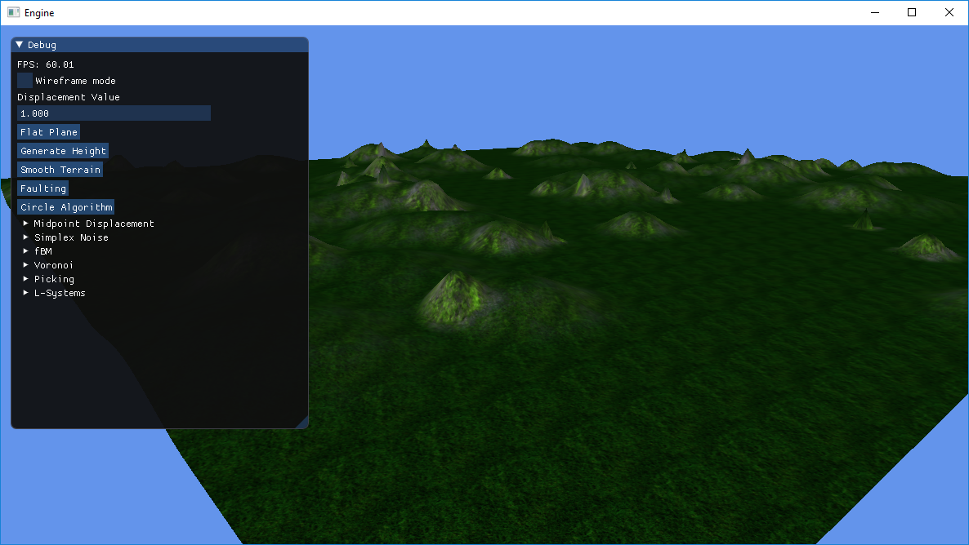

## Midpoint Displacement

The Midpoint Displacement function (as adapted from *Terrain Generation with Midpoint Displacement*) alters the terrains height by getting the “corners” y-position value and setting the mid-points y-value of these two “corners” to be an average of the two y-position values. This is the recursively done as it moves closer to the centre of the terrain.

Note: The terrain **must** be an odd value dimension for this function to work. E.g. 3, 5, 7, 9 etc.

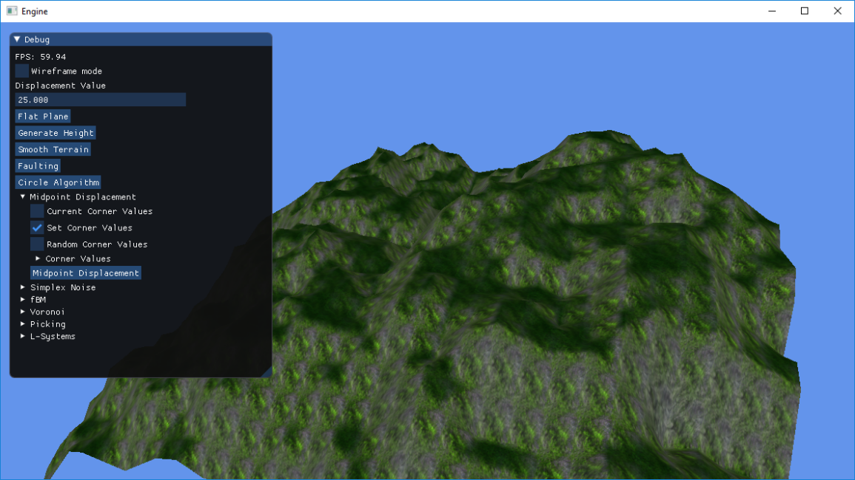

## Simplex Noise

The Simplex Noise function (as detailed in *Simplex Nosie Demystified*) utilises the simplex noise algorithm – a replacement for Ken Perlin’s “Classic Perlin Noise” algorithm.

This is an improvement of Perlin’s Class Noise algorithm in that it is less computationally complex, scales to higher dimensions with less computational cost and has no noticeable directional artefacts.

It works by sampling an array for a gradient value that you use to displace the entire terrain as you displace it based on its position.

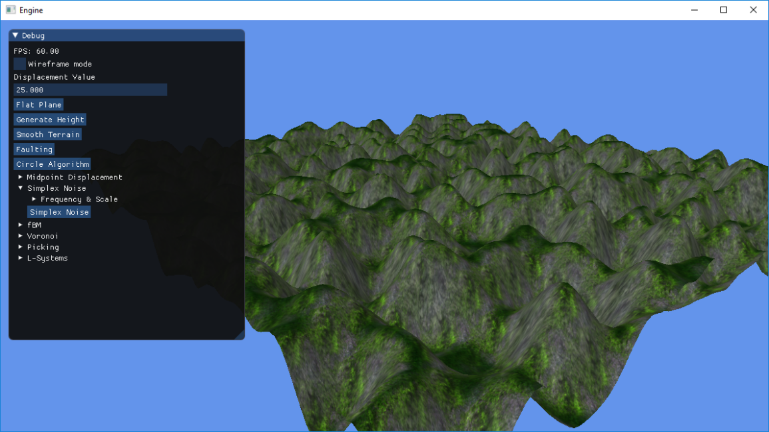

## Fractal Brownian Motion

More of an extension of a conventional noise function in that it would use something like Simplex Noise as a base (this application does) and merely repeats the noise function based on set values.

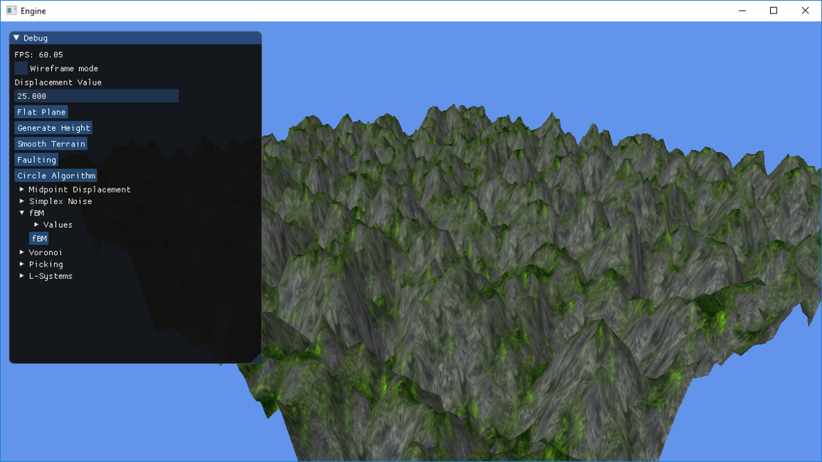

## Voronoi Regions

Like the fault line algorithm, the Voronoi Regions function splits the terrain into sections. This works by picking random points on the terrain, deciding (based on nearest distance to these random points) which “region” these points belong to, and then finally displacing the height based on what region it is in.

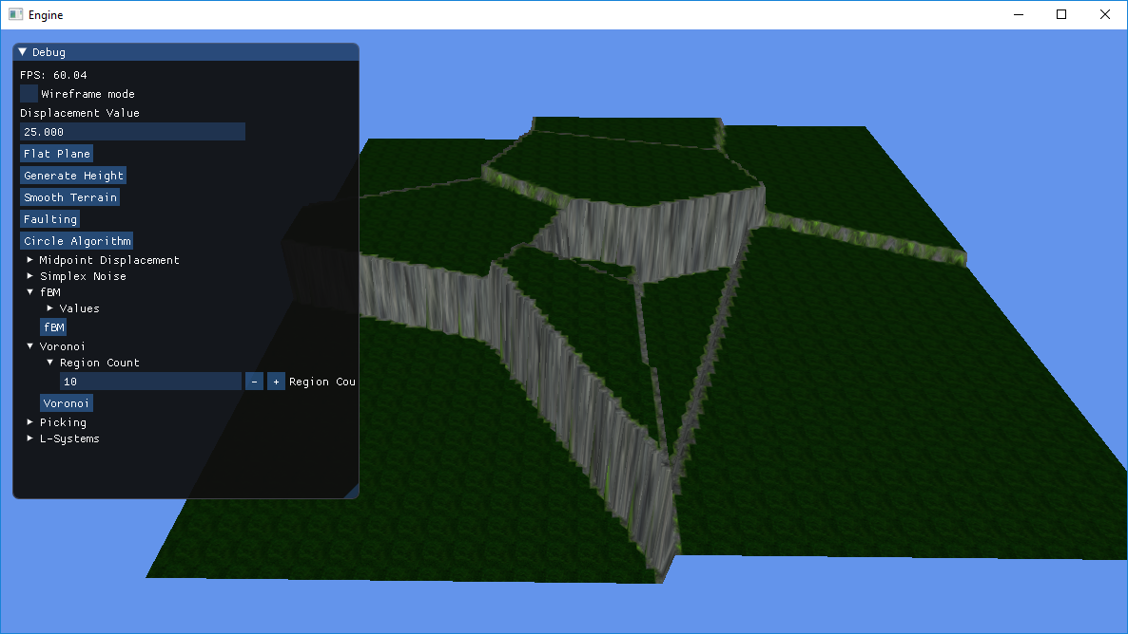

## Terrain Picking

Essentially, ray-casting. When it is enabled, and the user clicks on the terrain, the screen co-ordinates of the mouse are converted into world co-ordinates via calculating a directional vector from the cameras position to the terrain. Where this directional vector intersects the terrain, a check is done to see what specific vertices it is nearest to. For the vertices near this intersection point, the refined circle algorithm is used to displace them if they are near this point and in the radius of the circle in the algorithm.

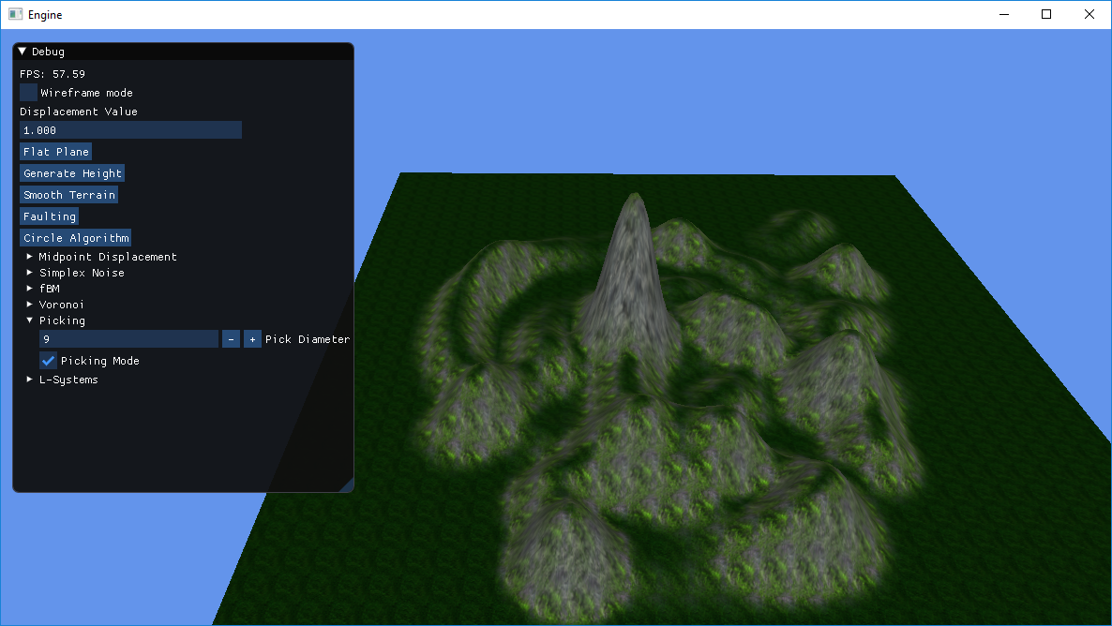

## L-Systems

Linden-Mayer systems or L-Systems are used to generate self-similar fractals. In this applications case, it generates a 2D river as it follows two specific rules. The L-System could be better integrated with the terrain, but this will be explored in more detail in the Critical Appraisal section. Based on a starting character, some input rules and an interpreter to determine what should be done when coming across certain character (E.g. F means move forward), a variety of shapes can be made.

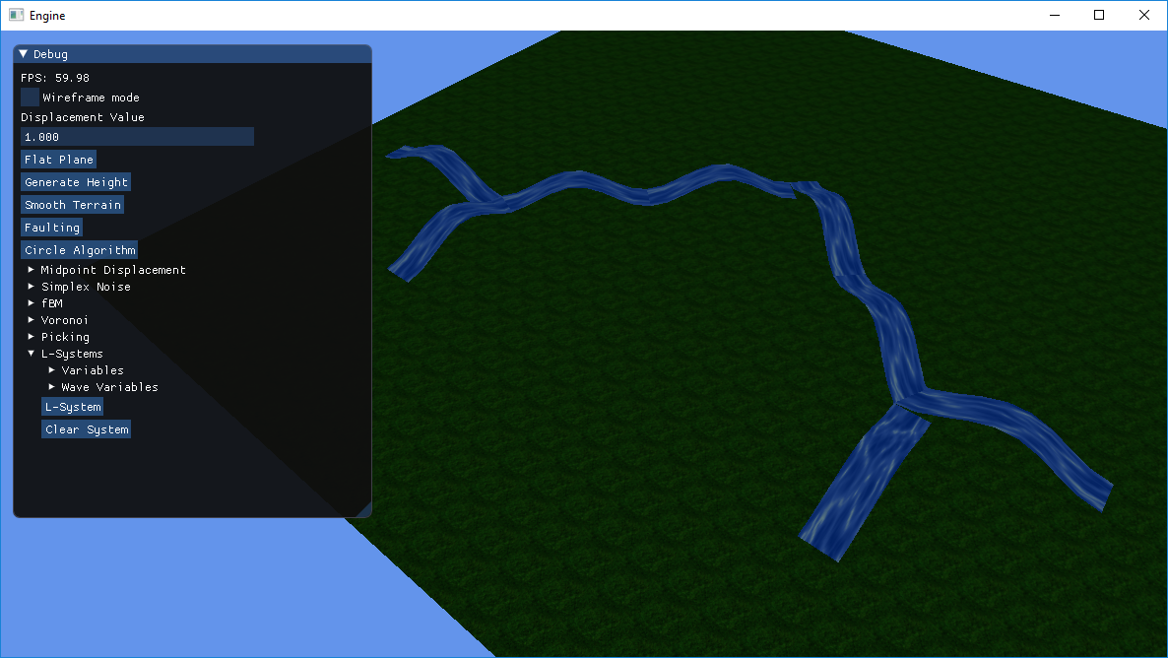

# Organisation

1. A description of your code organization: classes, data structures, separate code files etc. Include diagrams as required.

## Terrain

By far the largest class in the application. This is due to it containing all the functions (with the exception of Simplex Noise) necessary to alter the terrain. It inherits from the BaseMesh class which allows it to be more easily initialised.

It contains integers for width and height, as well as the texture repeat amount which is used to set how many times the texture will repeat over the terrain.

It contains an XMFLOAT2 to help scale the terrain, as the current implementation does not feature tessellation meaning that higher dimensions must be used (and subsequently scaled down) in order to have displaced terrain looking relatively smooth.

The remaining contents are the VertexType vertices array which is used to store all the data of the terrain (position, normals, texture co-ordinates) and a secondary indices array which is used in the Pick() function to be able to access the index array.

A simplex noise object is included in this class so that the terrain can be displace using simplex noise. This was done to reduce the number of Simplex Noise specific functions within the class.

A similar strategy was attempted with the Midpoint Displacement function although due to time constraints it never fully came to fruition.

The L-System class was also almost included in this class to allow the L-System to be better integrated with the terrain, however initial tests of merging these two systems proved too complex with the time remaining.

## L-System

The L-System class include the Manipulation Shader and Sizeable Quad classes. This is so that it can generate sizeable quads which will be used to render the L-System using the Manipulation Shader.

The rest of the class purely contains variables used in the generation of the L-System itself.

A starting character/string “axiom” which is used to start the L-System string generation off. A map which takes a character and string to contain the rules of the L-System. A stack of SavedTranform to save the position, rotation and world matrix at that point in the function. A vector of matrices which is used to render the quads of the L-System. A string which is used to show the current path of the L-System. And float 3’s to hold the initial position, current position and current rotation.

The float 3’s may not be used in the final iteration of the class as quads are generated used the saved world matrices.

## Sizeable Quad

This is a pretty simple class. Set up in a similar fashion to the Terrain class, it has a VertexType vertices array to hold position, normal and texture co-ordinate data, a float 2 used to scale the quad in the x and z directions and two floats for the width and height of the quad.

Initially it would take in the initial position and current position from the L-System class, however it became apparent that it would be easier to render *essentially* unit quads using the altered world matrices it received from the L-System class.

Other than what it mentioned above, it’s rendered using the Manipulation Shader class to displace its y-position based on its z-position along its normal.

These values can be altered via ImGui to refine the look of the wave movement.

## Simplex Noise

A class used to hold all the relevant data for the Simplex Noise algorithm. This was done to reduce the complexity of the Terrain class.

Its primary use it just to calculate what noise value should be applied to the terrain at a given position.

## Terrain Shader

A relatively simple class that inherits from the BaseShader class (which contains all the base values and variables used to initialise all shader classes).

Specifically this class is used to set up a shader for rendering the terrain.

It takes in the world, view and projection matrices alongside textures for the terrain and a light used for light calculation on the terrain.

## Manipulation Shader

A relatively simple class that inherits from the BaseShader class (which contains all the base values and variables used to initialise all shader classes).

Specifically this class is used to set up a shader for rendering the L-Systems quads.

It takes in the world, view and projection matrices alongside a texture for the quads, light used for light calculation on the on the quads and variables used to alter the wave motion of the quads.

# Critical Appraisal

1. A critical appraisal of your program in relation to code organization, efficiency of strategies and the decisions regarding alternative strategies and a critical evaluation of the success of your procedural content.

## Terrain Class

Non-utilisation of the GPU for semi-expensive calculations.

## L-System

More central integration with the terrain.

## Tessellation

Should have been utilised for both terrain and l-system.

## Overall

Giant success!

## Changes

Better texturing, lighting, use of tessellation.

# Reflection

1. Reflection on what has been learned, technically in terms of programming and also about procedural methods from undertaking the work, concentrating on being informative to someone else who might take on a similar task.

## Topics

## Further/Alternative Applications

# References

Elias Daler. 2019. Dear ImGui: Bloat-free Immediate Mode Graphical User interface for C++ with minimal dependencies. [ONLINE] Available at: <https://github.com/ocornut/imgui> [Accessed 23/04/2019]

Nic. 2013. Simple terrain smoothing. [ONLINE] Available at:

<http://nic-gamedev.blogspot.com/2013/02/simple-terrain-smoothing.html> [Accessed 23/04/2019]

Antonio Ramires Fernandes. 2019. The Fault Algorithm. [ONLINE] Available at:

<http://www.lighthouse3d.com/opengl/terrain/index.php?fault> [Accessed 23/04/2019]

Steve Losh. 2016. Terrain Generation with Midpoint Displacement. [ONLINE] Available at:

<http://stevelosh.com/blog/2016/02/midpoint-displacement/> [Accessed 23/04/2019]

Stefan Gustavson. 2005. Simplex noise demystified. [ONLINE] Available at:

<http://staffwww.itn.liu.se/~stegu/simplexnoise/simplexnoise.pdf> [Accessed 23/04/2019]

Patricio Gonzalez Vivo & Jen Lowe. 2015. Fractal Brownian Motion. [ONLINE] Available at:

<https://thebookofshaders.com/13/> [Accessed 23/04/2019]

Glare Technologies. 2019. Advanced Fractional Brownian Motion Noise. [ONLINE] Available at:

<https://www.indigorenderer.com/indigo-technical-reference/indigo-shader-language-reference/built-functions-%E2%80%93-procedural-noise-fun-0> [Accessed 23/04/2019]

Matej Zabsky. 2016. Procedural Terrain with Ridged Fractal Noise. [ONLINE] Available at: <https://stackoverflow.com/questions/36796829/procedural-terrain-with-ridged-fractal-noise> [Accessed 23/04/2019]

Red Blob Games. 2016. Making maps with noise functions. [ONLINE] Available at:

<https://www.redblobgames.com/maps/terrain-from-noise/> [Accessed 23/04/2019]

Paul Bourke. 1989. Efficient Triangulation Algorithm Suitable for Terrain Modelling. [ONLINE] Available at: <http://paulbourke.net/papers/triangulate/> [Accessed 23/04/2019]

Iedoc. 2015. Picking. [ONLINE] Available at: <https://www.braynzarsoft.net/viewtutorial/q16390-24-picking> [Accessed 23/04/2019]

Przemyslaw Prusinkiewicz & James Hanan. 2016. Lindenmayer Systems, Fractals, and Plants. [ONLINE] Available at: <http://algorithmicbotany.org/papers/lsfp.pdf> [Accessed 23/04/2019]

Richard Hawkes. 2016. Unity Algorithms – The Lindenmayer Series (L Series). [ONLINE] Available at: <https://www.youtube.com/watch?v=uBEA6VSUybk> [Accessed 23/04/2019]

Sher Minn Chong. 2018. L-Systems Renderer. [ONLINE] Available at: <http://piratefsh.github.io/p5js-art/public/lsystems/> [Accessed 23/04/2019]

Rastertek. Unknown. Slope Based Texturing. [ONLINE] Available at: <http://www.rastertek.com/tertut14.html> [Accessed 23/04/2019]

Xing Mei, Philippe Decaudin & Bao-Gang Hu. 2007. Fast Hydraulic Erosion Simulation and Visualization on GPU. [ONLINE] Available at: <http://www-evasion.imag.fr/Publications/2007/MDH07/FastErosion_PG07.pdf> [Accessed 23/04/2019]

Florian Bosch. 2011. WebGL Landscaping and Erosion. [ONLINE] Available at: <http://codeflow.org/webgl/craftscape/> [Accessed 23/04/2019]